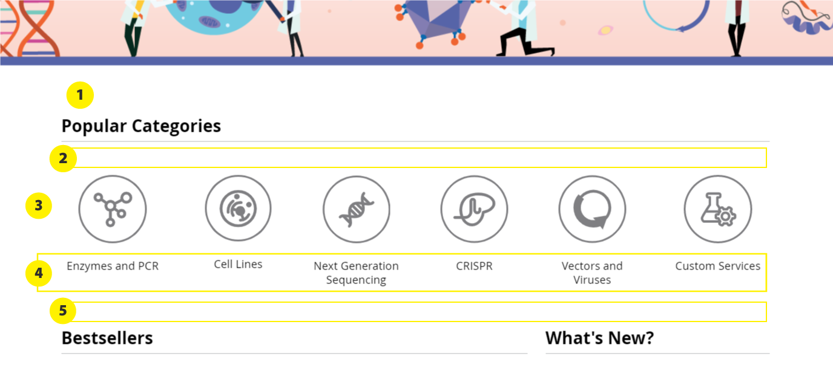

* **1:** 
  + padding-top: 50px 🡪 padding-top: 80px;
* **2:** 
  + margin-top: 28px 🡪 margin-top: 50px;
* **3:**
  + Can you horizontally spread out the icons more like in the mock-up above?
* **4:** 
  + “PCR” should be “Enzymes and PCR”
  + padding-top: 10px 🡪 padding-top: 20px;
  + font-size: 1.15em; [18px]
  + line-height: 125%;
  + On hover, text same color as the icon hover color
  + On hover, can both the text + icon change color together, e.g.:  
    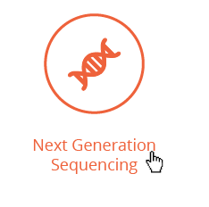  
    (and same when hover on the icon, text also changes into hover state)
* **5:** 
  + Add 45px of space

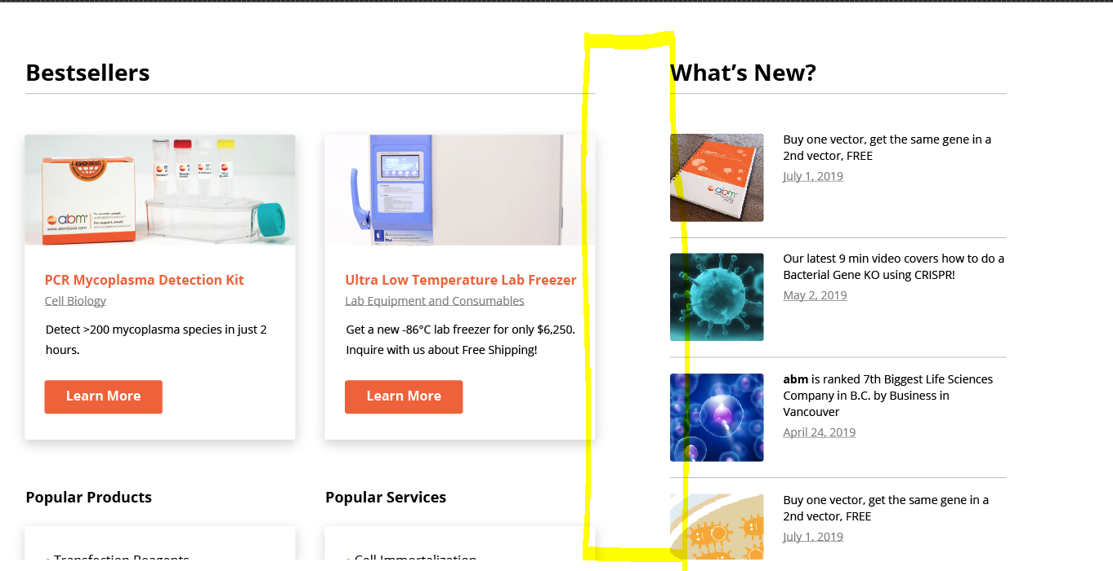

**Extra space between “Bestsellers” and “What’s New?” columns**

* Currently, the 3 columns are equal width and distance apart, and the two sections blend in together. Can you make it so that there’s extra space between the 2 sections, so that users can tell at a glance, that there’s 2 separate sections on the page?

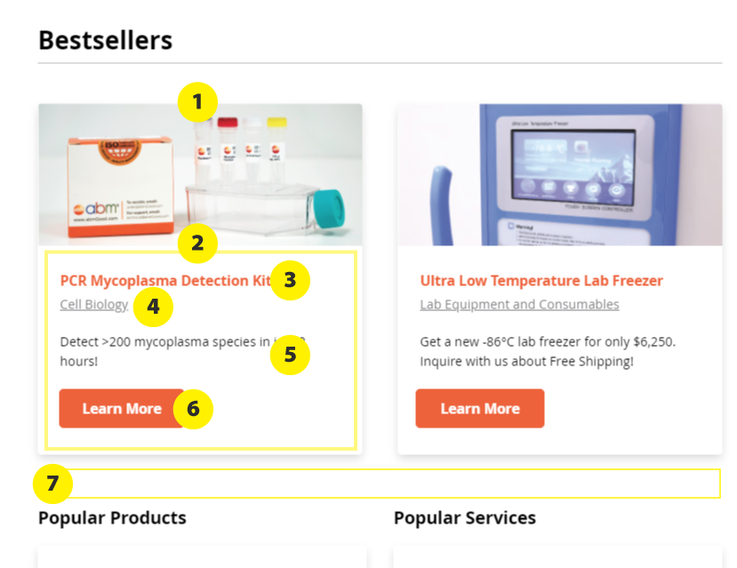

* **1: Box**
  + Remove border
  + box-shadow: 0px 3px 5px -5px rgba(0, 0, 0, 0.1),   
     0px 5px 10px rgba(0, 0, 0, 0.12);
    - Do we want to add browser prefixes? (-webkit-box-shadow & -moz-box-shadow)
  + padding-bottom: 20px;
* **2:**
  + padding: 10px 20px 10px 20px;
* **3: Orange text**
  + color: #ef6331;
  + Should also be a link (will go to the product page)
    - on hover: color: #ff734d;
  + padding-top: 10px;
  + padding-bottom: 2px;
* **4: Grey text**
  + font-size: 1.1em;
  + color: #808083;
* **5: Description text**
  + font-size: 1.1em;
  + line-height: 160%;
  + margin-top: 20px;
  + margin-bottom: 10px;
* **6: Button**
  + Reduce width of the button like in the mock-up
* **7:** 
  + Add extra 20px of space

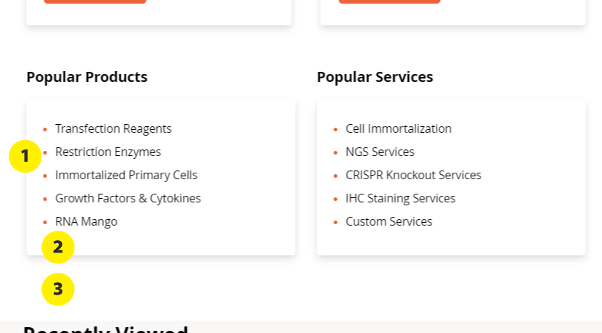

* **1:** 
  + ul:
    - padding-left: 20px;
  + ul li:
    - color: #ef6331; [I want to change the bullet color to orange]
* **2:** 
  + Add a View all link at the end of the list (like mock-up)
    - color: #808083;
    - Same font size as the list above
    - text-decoration: underline;
* **3:**
  + Add 50px of space at the bottom

-----------------------------------------------------------------------

I realized that the current layout for the “What’s New” section is hard to code for mobile. I updated the design so that it’ll be more flexible for different screen sizes.

I attached a PDF called **“Homepage-edits-v3-whatsnew.pdf”** that has details on the layout. The text and images in the PDF are just placeholders, so you can just use the images and text in the “What’s New” section that’s already on the Magento homepage. Let me know if this PDF is not clear enough.

<**script**>  
 **function** *togrey*(x) {  
 **var** str = **"images/home/icon_"** + x.**id** +**".svg"**;  
 x.**src** = url(**"<?php echo** $block->getViewFileUrl(**''**) **?>"**) + **"images/home/icon_"** + x.**id** +**".svg"**;  
 **document**.getElementById(x.**id**+**"-des"**).**style**.**color** = **"#000"**;  
 }  
  
 **function** *toorange*(x) {  
 x.**src** = **"https://magento.abmgood.com/pub/static/version1558684179/frontend/Abm/style/en_US/images/home/icon_"** + x.**id** + **"1.svg"**;  
 **document**.getElementById(x.**id**+**"-des"**).**style**.**color** = **"#ef6331"**;  
 }  
 **function** *togreydes*(x) {  
 x.**style**.**color** = **"#000"**;  
 **document**.getElementById(x.**id**.replace(**"-des"**,**""**)).**src** = **"https://magento.abmgood.com/pub/static/version1558684179/frontend/Abm/style/en_US/images/home/icon_"** + x.**id**.replace(**"-des"**,**""**) +**".svg"**;  
 }  
  
 **function** *toorangedes*(x) {  
 x.**style**.**color** = **"#ef6331"**;  
 **document**.getElementById(x.**id**.replace(**"-des"**,**""**)).**src** = **"https://magento.abmgood.com/pub/static/version1558684179/frontend/Abm/style/en_US/images/home/icon_"** + x.**id**.replace(**"-des"**,**""**) + **"1.svg"**;  
  
 }  
</**script**>